Site Details
Name: | Roadford Lake
Location: | Broadwoodwidger, Lifton, PL16 0RL | Grid reference: SX 42623 91312 | What Three Words | ///scanty.centuries.directive
Description: | A man-made reservoir located off the A30 Nr Launceston. Primary uses of water supply and public access – including forestry trails
Site Risk Context
Level of Development:
Level of visitor use:
Level of visitor skill and self-reliance:
Level of management intervention:
Incident history:
Notes on Site Management
The South West Lakes team staffs the site, they have offices and a regular presence but are on occasions required to work at other locations. There is also an onsite café with seasonal opening hours operated by SWLT. The site also benefits from children’s play area, P&D car park (Automatic number plate recognition in place), public toilets, picnic benches, dog exercise area and mobility Tramper hire.

There is a campsite and Activity centre including members, but this assessment does not seek to address the technical activity provision and associated management. These are covered through separate assessments and procedures in line with industry practice, guidance and legislation.

A Public Safety Framework (PSF) exists for the site and sets out inspection criteria and frequency for visitor infrastructure. Any physical controls identified in this assessment should be included in the PSF and therefore monitored and inspected through that process only to avoid duplication.

Visitor signage is in place at key access points; this includes key information relevant to water safety in line with best practice and Visitor Safety Group principals. Further activity specific information is provided to users who access other services such as hire of the Tramper.

This risk assessment follows the principles of the Visitor Safety Group, of which South West Lakes are active members
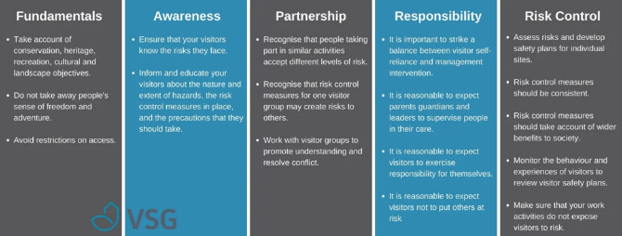

Managing Visitor Safety in the Countryside – Principles and Practice” Visitor Safety Group. October 2019.

Document Tracking
Previous version: | Date |  | Title
Review: | Date |  | Title
Review: | Undertaken by
Approval: | Date |  | Name
Approval: | Signature
Zoned Map(s) of Site
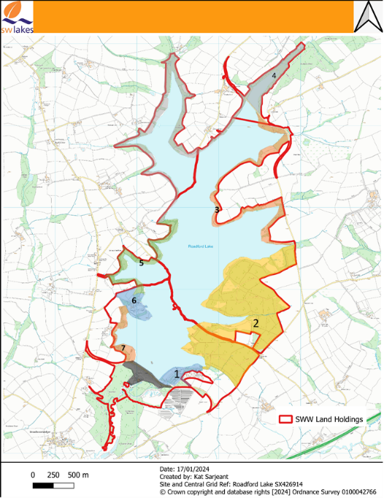
Numbered zones relate to Sections of the below risk assessment, defined by changes in Development, visitor use or significant changes in terrain.
- Main recreational zone including public facilities, Cafe, play area and campsite. Other Risk assessments cover this area
- Main trails leading to points of interest with little additional land holdings, with further trails through forestry and additional small carparks
- Less used access path and angling areas with meadows and woodlands leading to causeway and bird hides
- SWW designated Nature reserves and no access areas with, woodland, meadows and farmland.
- Reservoir walks access paths varying between open grass and forest areas.
- Activity centre area, with campsites water access and facilities- other risk assessments cover this area
- Footpath section leading from road to activity centre through woodland and meadow,

Black Shaded areas indicate SWW operation areas, which are outside of SWLT responsibly and management, - and recommendations will be shared but not assumed to be implemented.

The letters relate to photos of significant features of concern Included in the risk assessment

The below assessment is structured to follow the Visitors journey from the main carpark/entrance/centre around the site.
Blue shading refers to water related/or specific hazards

Zonal Risk Assessment
Zone | People at Risk | Terrain | Features/Concerns (Photo) | Typical related accidents | Current Controls | Additional Actions/ Recommendations (Assigned responsible person and time frame) | Justification | Target date for completion | Responsible | Completed (Initial and Photo
 |  |  |  |  |  |  | .

